**LITERACY AT WEXFORD CSA**

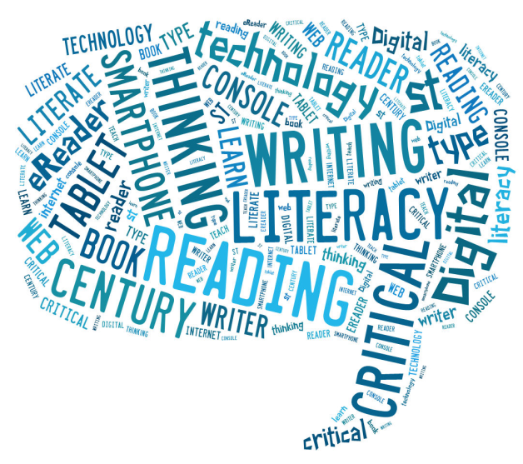

The Ontario Secondary School Literacy Test (OSSLT), administered by Ontario’s Education Quality and Accountability Office (EQAO), is used to determine whether a student has the literacy (reading and writing) skills required to meet the standard for understanding reading selections and communicating in a variety of writing forms, as expected by *The Ontario Curriculum* across all subjects up to the end of Grade 9. The successful completion of this test or the Ontario Secondary School Literacy Course is a requirement for the Ontario Secondary School Diploma.

Below are all our initiatives and important dates. We encourage you and your student to be involved. We encourage all to participate!

**C:\Program Files (x86)\Microsoft Office\MEDIA\CAGCAT10\j0293844.wmf**

**Tuesday, October 18th – Literacy Diagnostic**

All grade 10s will write booklet #1 in their Period 2 class.

**C:\Program Files (x86)\Microsoft Office\MEDIA\CAGCAT10\j0293844.wmfThursday October 20th – Diagnostic Rewrite for Absent Students**

Students, who did not write, will write in the Resource Center during period 2. They will return to class with an excusal note.

**C:\Program Files (x86)\Microsoft Office\MEDIA\CAGCAT10\j0293844.wmfWednesday October 26th – Information for Parents**

Information about the OSSLT and EQAO will be provided to parents at Parent Teacher Interviews.

**C:\Program Files (x86)\Microsoft Office\MEDIA\CAGCAT10\j0293844.wmfMonday October 31st – Diagnostic Results and After School Literacy Classes**

Results will go home with students in their Period 2 class. Please discuss and make decisions about preparations for the OSSLT; the booklet will be available for review in the After School Literacy Classes. Sign up lists for After School Literacy classes will be available in the period 2 class.

**C:\Program Files (x86)\Microsoft Office\MEDIA\CAGCAT10\j0293844.wmfTuesday November 1st – After School Literacy Classes (ASL) on Booklet #1**

* After School Literacy Classes (ASL) run Monday/Wednesday OR Tuesday/Thursday3:15- 4:00pm
* Covers all of Booklet #1
* Small snack provided
* Ends December 22nd

**C:\Program Files (x86)\Microsoft Office\MEDIA\CAGCAT10\j0293844.wmfFebruary 6th - After School Literacy Classes (ASL) Resume on Booklet #2**

* After School Literacy Classes (ASL) run Monday/Wednesday OR Tuesday/Thursday
* 3:15-4:00pm
* Covers all of Booklet #1
* Small snack provided
* Ends March 29th

**C:\Program Files (x86)\Microsoft Office\MEDIA\CAGCAT10\j0293844.wmfMarch 30th – The Writing of the Ontario Secondary School Literacy Test (OSSLT)**

* 9:00 am writing, no afternoon classes
* Results provided by EQAO in June

For more information, please see <http://www.eqao.com/en/assessments/OSSLT/students/Pages/students.aspx>

# How Parents Can Encourage Teens to Read

##### Adapted from materials from Reading Is Fundamental.

You know that reading is important and you want to make sure that your teenager grows into adulthood with all the skills they need to succeed. The following list offers suggestions for encouraging your teens to read.

1. **Set an example**. Let your kids see you reading for pleasure.

2. **Furnish your home with a variety of reading materials**. Leave books, magazines, and newspapers around. Check to see what disappears for a clue to what interests your teenager. Free newspapers, such as NOW magazine or Metro News are available across the GTA!

3. **Give teens an opportunity to choose their own books**. When you and your teen are out together, browse in a bookstore or library. Go your separate ways and make your own selections. Your local library is a great place to borrow books.

4. **Build on your teen's interests.** Look for books and articles that feature their favorite sports teams, rock stars, hobbies, or TV shows. If you give your teen a subscription to a special interest magazine is a great choice to support literacy.

5. **View pleasure reading as a value in itself.** Almost anything your youngsters read — including the comics — helps build reading skills.

6. **Read some books written for teens.** Young adult novels can give you valuable insights into the concerns and pressures felt by teenagers. You may find that these books provide a neutral ground on which to talk about sensitive subjects.

7. **Make reading aloud a natural, fun part of family life**. Share an article you clipped from the paper, a poem, a letter, or a random page from a website — without turning it into a lesson.

8. **Acknowledge your teen's interests**. Look for ways to acknowledge the emerging adult in your teens by suggesting some adult reading you think they can handle. This will help develop critical thinking and provide an opportunity to build vocabulary.

9. **Power down before bed.** Spend 30 minutes before bed away from screens, such as smartphones, the television or computer. This will help support your teen’s sleep cycle and provides a great opportunity to read or journal before turning in for bed.

##### See more about adolescent literacy at: <http://www.adlit.org/article/23399/>